Lab 6 : Your First Ingestion Pipeline: File to Redpanda

Table of Contents
Table of Contents 2
Introduction 3
Learning Objectives 3
Prerequisites 4
Retrieve Cloud Credentials 5
Part 1 — Prepare the Source Data 8
Step 1 — Create the Output Topic 8
Step 2 — Create the Mock Data File 8
Part 2 — Build the YAML Pipeline 9
Step 1 — Create the Pipeline Configuration 9
What's Happening? 9
Part 3 — Run Redpanda Connect 11
Part 4 — Verify the Output 12
Knowledge Check 13
Troubleshooting 13
Symptom: Container errors out with "no such file or directory" 13
Symptom: Authentication Failed / EOF / Timeout 13
Next Steps 14
Conclusion 14

Introduction
Redpanda Connect uses a declarative YAML architecture. Instead of writing custom application code to integrate systems, you simply declare an input, optional processors, and an output.
In this lab, you will build your very first Redpanda Connect pipeline. We will simulate a common data engineering task: ingesting historical data from a static file and streaming it into a Redpanda Serverless topic.

Learning Objectives
Upon completing this lab, you will be able to:
- Understand the basic structure of a Redpanda Connect YAML configuration.
- Use the prebuilt file input connector.
- Authenticate Redpanda Connect to a Serverless cluster.
- Run Redpanda Connect locally via Docker to process data into the cloud.

Prerequisites
Before starting, ensure you have:
- rpk installed on your machine.
- Docker installed and running.
- A Redpanda Cloud account (Serverless tier).
Verify Docker is running:
docker ps

Authenticate to Redpanda Cloud
Connect your local rpk tool to your Serverless cluster:
1. Log in to your Cloud account:
rpk cloud login

2. Select your Serverless Cluster:
rpk cloud cluster select

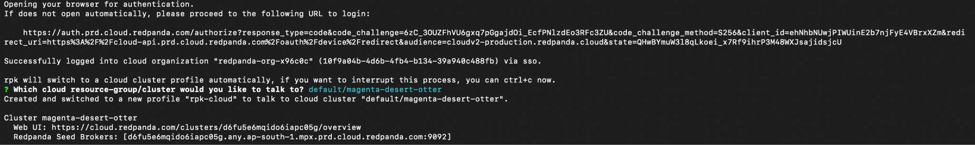

3. Verify your connection:
rpk cluster info

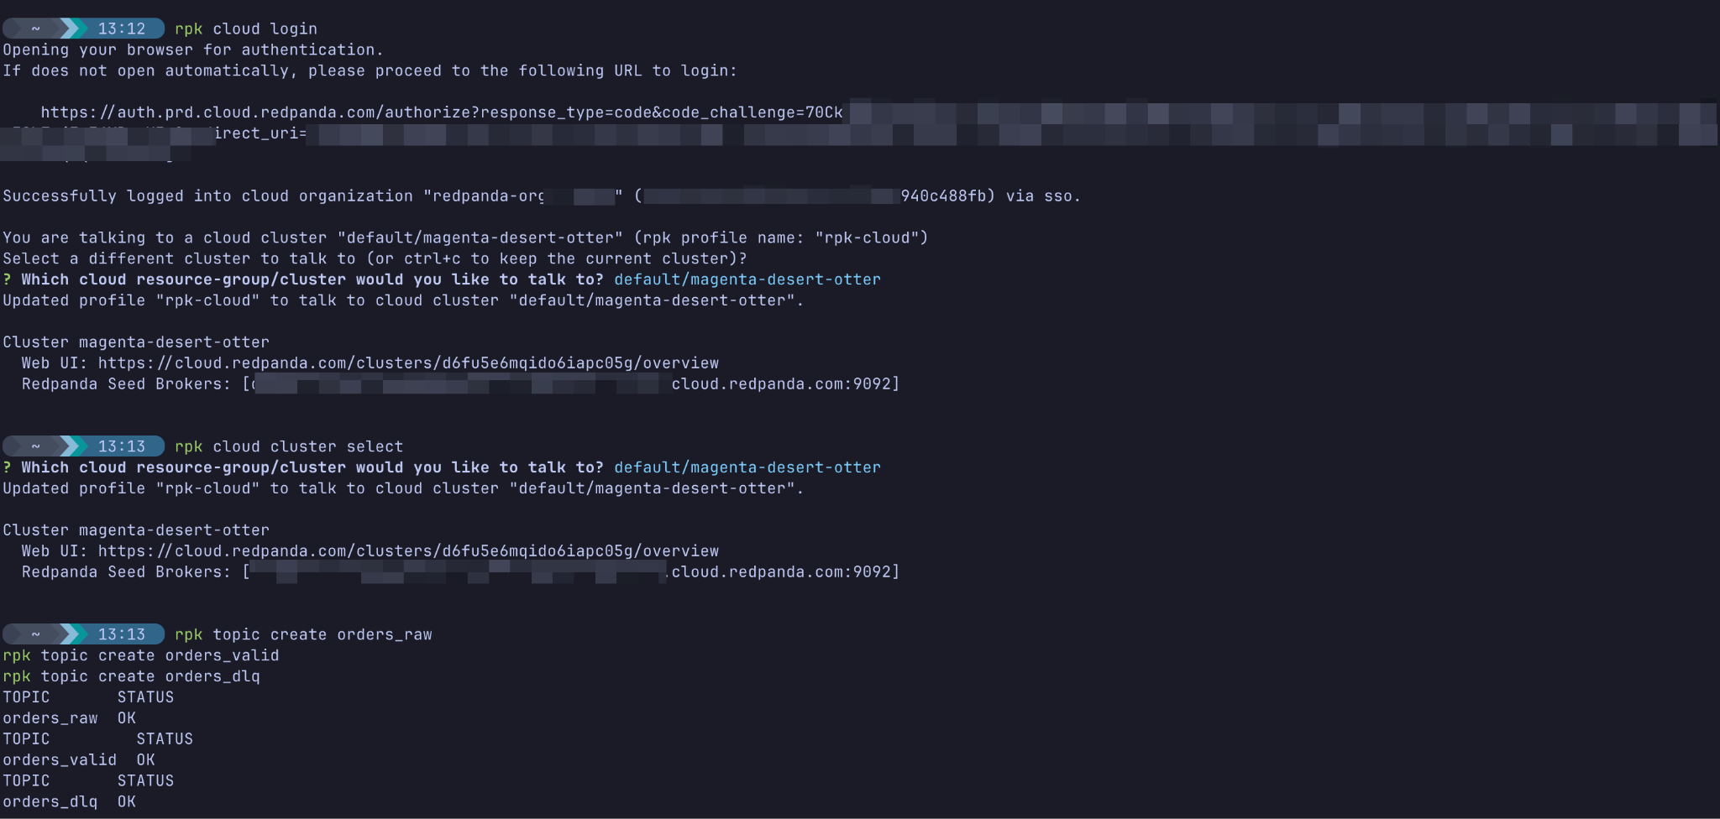

Retrieve Cloud Credentials
For the Python script in Part 2, you will need to authenticate securely. You can find these details in the Redpanda Cloud UI:
1. Create a User (if you haven't already in Lab 1):
- In the Redpanda Cloud UI, navigate to Security on the left sidebar.
- Click Users -> Create User.
- Create a user and securely save the username and password
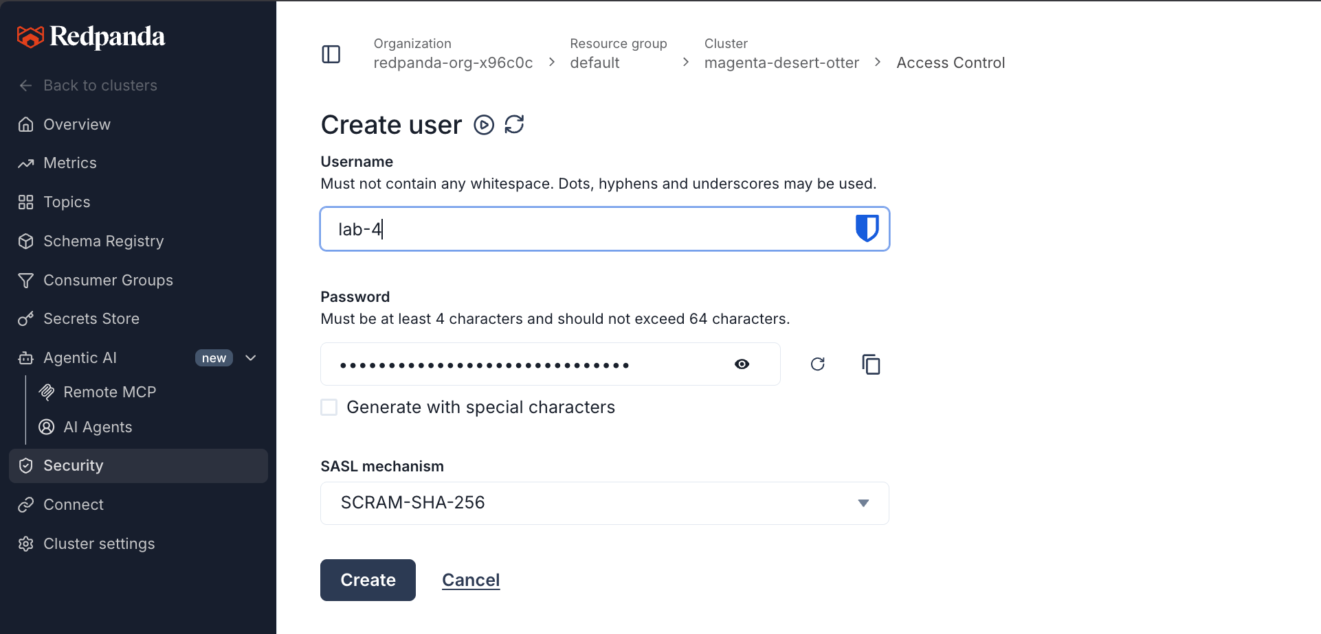
- Next, switch to the ACLs tab (still under Security) and click Create ACLs.
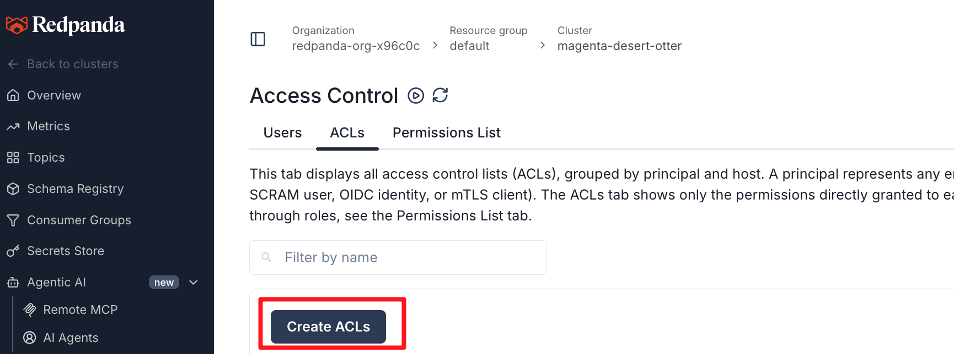
- In the User / principal field, enter the name of the user you just created (e.g., student).
- Click the Allow all operations button on the right side (this easily grants necessary access for lab testing).
- Click Create at the bottom to apply the permissions.
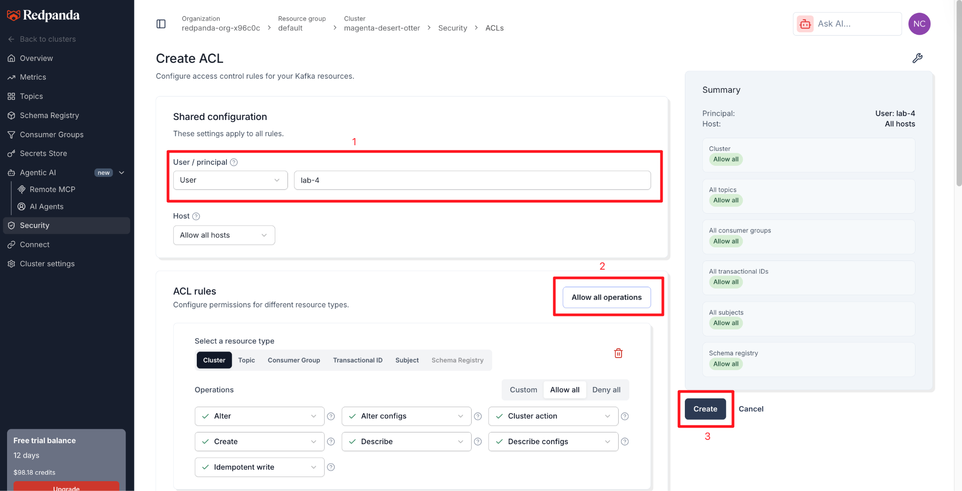
2. Find your Connection Details:
- Navigate to Overview on the left sidebar.
- Scroll down to the How to connect section.
- Click on the Kafka API tab (next to the CLI tab).
- Copy your Bootstrap server URL (it will look similar to d6fu5e6mqido6iapc05g.any.ap-south-1.mpx.prd.cloud.redpanda.com:9092).
- Notice the configuration values listed here: SASL mechanism (SCRAM) and Security protocol (SASL_SSL). We will explicitly use these in our YAML code.
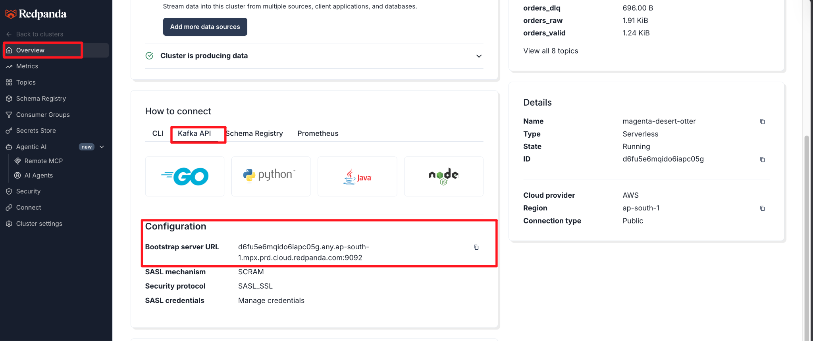

Part 1 — Prepare the Source Data
First, let's create a cloud topic to hold our ingested data.

Step 1 — Create the Output Topic
rpk topic create historical-orders
Expected Output:
TOPIC STATUS
historical-orders OK
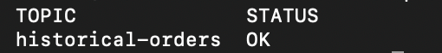

Step 2 — Create the Mock Data File
Create a directory for your lab and navigate into it:
mkdir ~/rp-connect-labs
cd ~/rp-connect-labs
Create a file named orders.json:
nano orders.json

Paste the following mock data into the file:
{"order_id": "A-100", "status": "shipped", "amount": 45.50}
{"order_id": "A-101", "status": "pending", "amount": 12.00}
{"order_id": "A-102", "status": "shipped", "amount": 89.99}
{"order_id": "A-103", "status": "canceled", "amount": 5.00}

(Save and exit using Ctrl+X, Y, Enter).

Part 2 — Build the YAML Pipeline
Now, we will define our Connect pipeline.

Step 1 — Create the Pipeline Configuration
Create a file named file_to_redpanda.yaml:
nano file_to_redpanda.yaml

Paste the following YAML configuration. Remember to update the Serverless connection settings with the values you gathered in the Prerequisites!
input:
file:
paths: [ "/data/orders.json" ]
codec: lines
pipeline:
processors: [] # No transformations for this lab
output:
kafka:
addresses: [ "YOUR_BOOTSTRAP_SERVER_URL:9092" ]
topic: "historical-orders"
tls:
enabled: true
sasl:
mechanism: SCRAM-SHA-256
user: "your_username"
password: "your_password"
(Save and exit).

What's Happening?
- input.file: Instructs Connect to read from a file path. We use the lines codec to process each line of the file as a distinct, individual message.
- processors: Empty for now. We are doing a direct pass-through.
- output.kafka: Uses the prebuilt Kafka connector to securely stream the data into your Redpanda Serverless cluster using TLS encryption and SCRAM authentication.

Part 3 — Run Redpanda Connect
We will run Redpanda Connect as a lightweight Docker container.
We need to mount our local folder ($(pwd)) to the /data folder inside the container so that Connect can access both our YAML file and our orders.json file.
Run the following command:
docker run --rm -it \
-v $(pwd):/data \
redpandadata/connect:latest \
-c /data/file_to_redpanda.yaml

Expected Output:
You should see logs indicating that Redpanda Connect has started, read the file, and successfully sent the messages. Because it reaches the end of the static file, the pipeline will automatically shut down and exit gracefully once the data is fully ingested.

Part 4 — Verify the Output
Let's ensure the data actually made it to your Serverless cluster.
Use rpk to consume the topic:
rpk topic consume historical-orders --offset oldest

Expected Output:
{
"topic": "historical-orders",
"value": "{\"order_id\": \"A-100\", \"status\": \"shipped\", \"amount\": 45.50}",
"offset": 0
}
{
"topic": "historical-orders",
"value": "{\"order_id\": \"A-101\", \"status\": \"pending\", \"amount\": 12.00}",
"offset": 1
}
(Press Ctrl+C to exit).
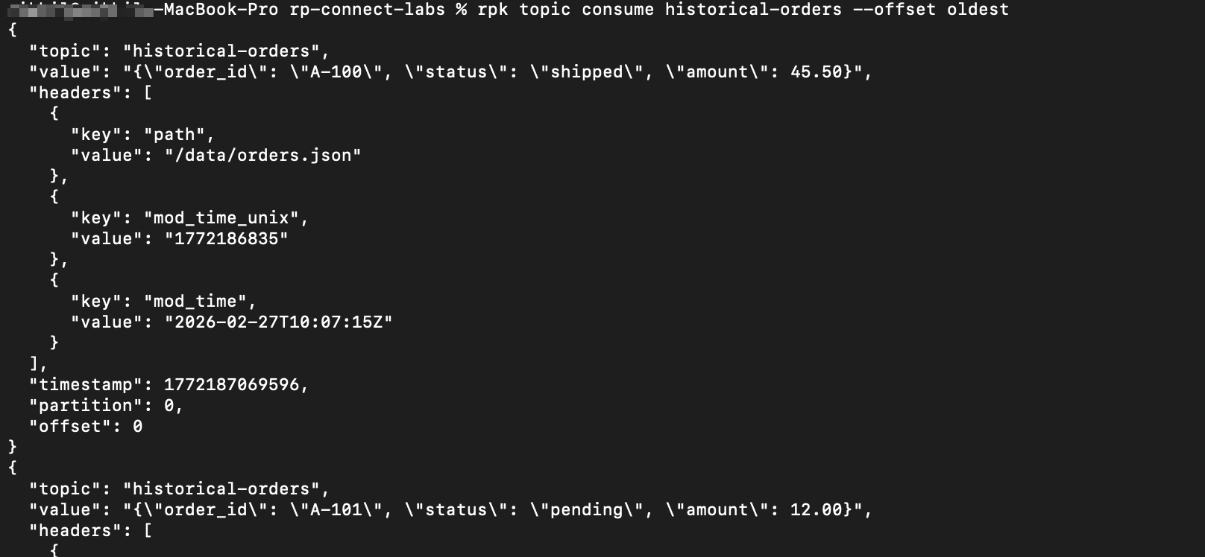
You can also log into the Redpanda Cloud UI, navigate to Topics -> historical-orders -> Messages, and view your ingested data visually!

Knowledge Check
- What are the three core sections of a Redpanda Connect YAML file?
- Answer: input, pipeline (processors), and output.
- Why did the Redpanda Connect container stop automatically after running?
- Answer: The file input is a finite data source. Once it reached the end of orders.json, it cleanly gracefully shut down the pipeline.
- What does the codec: lines setting do?
- Answer: It tells the connector to treat each individual line in the file as a separate message, rather than sending the entire file as one giant payload.
- Why did we need tls and sasl blocks in our YAML?
- Answer: Redpanda Serverless exposes endpoints securely over the public internet, requiring encryption (SSL/TLS) and authentication (SASL).

Troubleshooting

Symptom: Container errors out with "no such file or directory"
Solution: Ensure you are running the Docker command from inside the ~/rp-connect-labs directory so the -v $(pwd):/data volume mount captures your files correctly.

Symptom: Authentication Failed / EOF / Timeout
Solution: Double-check your YAML file. Ensure addresses contains your exact Bootstrap Server URL, and your user and password match your Cloud UI credentials. Ensure tls: enabled: true is properly indented under the kafka block.

Next Steps
Clean up your local environment (we will reuse the cloud topic in the next lab):
rm file_to_redpanda.yaml

Proceed to next lab, where you will swap the file input for an http_server input to catch live real-time webhook events.

Conclusion
In this lab, you successfully built your first declarative pipeline. You learned how to use the file input connector and the kafka output connector to bridge local historical data directly into a secure cloud streaming environment, all without writing a single line of custom application code.

